**Abstract Reasoning Easy**

**1.**  
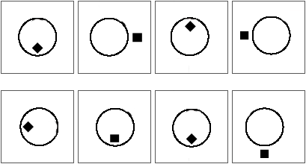

In the abstract reasoning sequence displayed above, two distinct patterns can be observed:

* Placing a square or rhomb alternating within or outside the circle.
* Each additional figure changes the location of the square / rhomb by a quarter turn counterclockwise rotation.

This results in the alternately placing of a rhomb and square, respectively, within and outside the circle, keeping in mind that the change of position follows the quarter turn counterclockwise rotation. The solution to this abstract reasoning sequence is **therefore the 4th one**, where the square is positioned at the bottom and outside the circle.

**2.**  
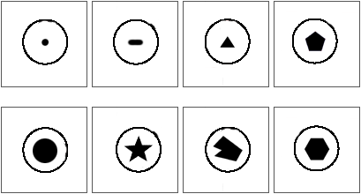

In this test the degree of symmetry of the figure placed within the circle decreases step by step. The pattern starts with a circle, a line, a triangle and so on, continuing with lower symmetry objects (and thus more side faces). This automatically results in a **hexagon placed in the circle** as the solution for this abstract reasoning sequence.

**3.**  
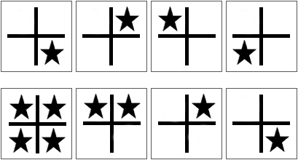

The sequence above clearly shows that the position of the star around the cross is the key to solving this sequence. As the sequence continues the location of the star is determined by a quarter turn counterclockwise rotation every next figure. **This results in the 4th solution where the star is positioned at the bottom right part of the cross.**

**4.**  
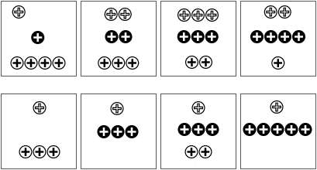

In the abstract reasoning sequence displayed above, three distinct patterns can be observed:

* The uppermost white circles with white crosses increase at first in number, after which the amount of circles decrease in number again with increasing sequence.
* De inner black circles with white crosses increase in number with increasing sequence.
* The undermost white circles with black crosses decrease in number with increasing sequence.

**Therefore the solution to this abstract reasoning sequence will consist of 1 uppermost circle, 5 middle ones and none at the bottom.**

**5**  
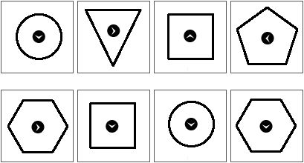

In the abstract reasoning sequence displayed above, two distinct patterns can be observed:

* As a basis the pattern consists at first of a circle, the highest form of symmetry. This degree of symmetry decreases as the sequence increases which results in objects with more side faces.
* Within these objects an arrow is present, which will be rotated counterclockwise by a quarter turn with every next figure in the sequence.  
  **This results in a hexagon with the inner arrow directed downwards.**

**6**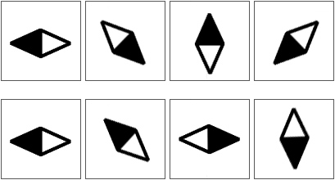

Knowing the pattern of the position of the rhomb in the above sequence is the key to solving this sequence. The rhomb is rotated 450 counterclockwise in every following figure, at which the colors within the rhomb alternate with each rotation. **The solution to this sequence therefore is a horizontal rhomb with the white side to the left.**

**7.**  
Non verbal reasoning easy test
 question 7

The above sequence should be seen as a series of stacked squares with alternating colors. At every next figure in the sequence the uppermost square is removed**, to end up with a black square**.

**8**  
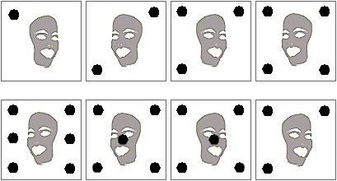

In this sequence two distinct patterns can be observed.

* The persons face is alternately displayed from aside by increasing sequence.
* The amount of black circles increases with increasing sequence.

**This results in a person looking to the right with 5 black circles in the figure.**

 

**Astract Reasoning Hard**

**9**  
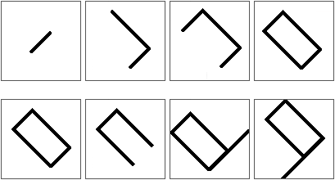

A rectangle is formed in parts in the above abstract reasoning sequence. When modeling the next rectangle, the first line of this second rectangle will be placed on top of the first line of the first rectangle. This means that in a 3d view you would see depth in this figure. Since this is a 2d view of the rectangle, it seems after modeling the first rectangle nothing is changed anymore. **The correct answer for this 2d view is therefore the first one, which only shows a rectangle.**

**10**  
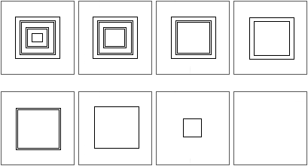

A decrease in the amount of central squares with increasing sequence is the pattern in the sequence displayed above. However, this decrease is not steady; the first decrease consists of 1 central square, the second of 2 and the third again of 1, so the pattern is repeating itself with a decrease in the amount of central squares**. The solution to this abstract reasoning sequence will thus be a blank space.**

**11**  
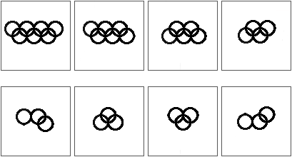

The number of circles decreases with increasing sequence in the picture displayed above. This decrease starts right at the top, moves to the left top and then continues at the right and left bottom respectively. This pattern is repeated over and over again until no circles are left. **That means that the correct answer in this case the third image is.**

**12**  
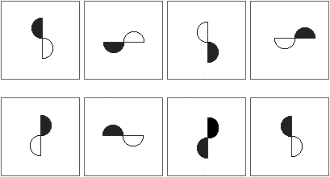

The object in the figure above is rotated counterclockwise with increasing sequence, to create new images as the sequence continues. **The solution is therefore a vertical object, with in this case the black side to the left as a result of the rotation**.

**13**  
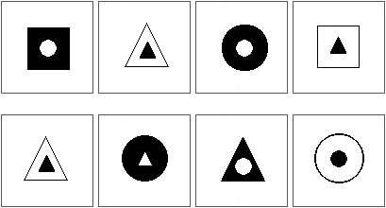

In the abstract reasoning sequence displayed above, three distinct patterns can be observed:

* The image consists of a basic object containing a secondary object. These objects are color incompatible and exchange color every next image in the sequence.
* As the sequence progresses the degree of symmetry of the basic object decreases (a circle has the highest degree of symmetry). This pattern of symmetry is repeated.
* Next to that there is a difference when the pattern is repeated. The first pattern consists of the same basic as secondary object. The second pattern however, consists of the secondary object of its right neighbor image. **This means that the solution consists of a black triangle as basic object and a white circle as secondary object. This is the third solution.**

**14**  
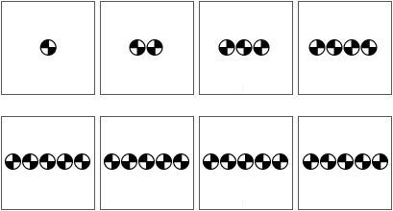

The sequence starts with a circle containing a defined pattern. Next, a second circle with its own pattern is placed at the right of the first circle. Subsequent a third circle with again a defined pattern is placed to the left, next to the already existing circles. In this way the amount of defined circles increases as the sequence increases, keeping in mind that the new circles are placed alternately to the right and left respectively. **This results in the second solution.**

**15**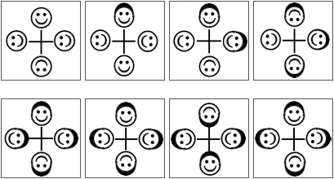

In the abstract reasoning sequence displayed above, two distinct patterns can be observed:

* In every following figure in the sequence a smiley will be obtaining a hat.
* The difficulty in this sequence is the change in position of the smiley with increasing sequence. The smiley obtaining the hat will keep its position. The one on the right and across the one receiving the hat however, will rotate 1800. Be aware of the fact that only the smiley rotates and not the hat. When a smiley with a hat needs rotation, only the smiley rotates, resulting in a smiley with a beard.

**The solution to the sequence therefore consists of all smileys wearing hats / beards.** The fourth figure of the sequence shows that only the uppermost and the right smiley should be rotated. This results in the fourth solution.

**16**  
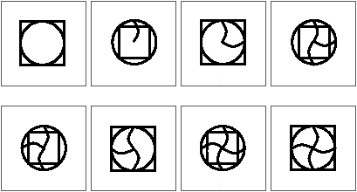

In the abstract reasoning sequence displayed above, two distinct patterns can be observed:

* As basic objects you have squares containing circles and vice versa present in the figure.
* Next to that curls show up with increasing sequence, starting at the top and placed clockwise.

**This results in a square containing a circle and 4 curls.**

**17**  
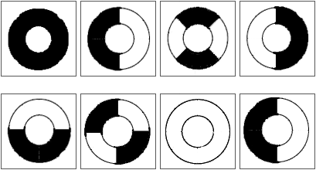

The abstract reasoning sequence above consists of white and black circles. The sequence starts with one black circle and continues with circles consisting of two and four parts respectively. Next the amount of circle parts in decreased again to end up with one monochrome circle. In this case a **white circle, which is in agreement with the third solution.**

**18**  
Non verbal reasoning hard test
 question 10

In this sequence the time displayed on the clockworks is of importance to solving the row. The uppermost left clockwork displays a time of 9.00h, the second 9.45h, the third 11.15h and the last one 14.15h. A closer look at these times reveals that the difference between the first two clockworks 45 minutes is, between the second and third 90 minutes and between the last two 180 minutes. Repeating this pattern, results in a difference between the fourth and fifth clockwork of 360 minutes. The time displayed on the clockwork should thus be 20.15, which is **the second solution on the left.**

**19**  
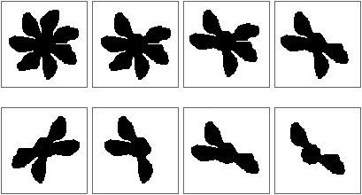

In this abstract reasoning sequence the amount of leaflets is decreased as the sequence is increased. First the uppermost left leaflet will fall off, then the undermost left leaflet. Next the uppermost right leaflet will disappear, after which the logical next step will be the removal of the undermost right leaflet and thus **resulting in the third answer.**

**20**  
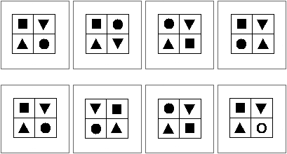

In order to obtain the answer from the sequence displayed above, the objects displayed in the first figure of the sequence should switch places with each other:

* First the two most right objects switch places with each other, resulting in the second figure.
* Next, the circle and square will change places, resulting in the third figure. This means that switching of the objects occurs clockwise.
* The next switch in place therefore takes place between the circle and the square, which results **in the fourth figure.**

A logical next step will be switching the triangles. However, since these objects are the same, the solution to this sequence will be the same as the figure we started the switching procedure with.

**21**  
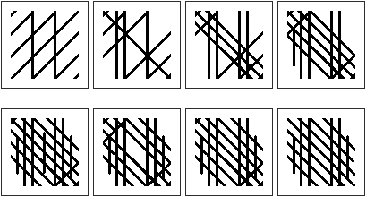

In the abstract reasoning sequence displayed above, three distinct patterns can be observed:

* In every next figure in the sequence a vertical line will be added
* Next to that also a diagonal line (uppermost left to undermost right) will be added at both sides in every following figure. Since the first figure does not contain such a diagonal, the second figure will contain 1 diagonal. In the following figures a diagonal at both sides of this starting one will be placed.
* The last pattern in this sequence contains the removal of diagonals (uppermost right to undermost left). This removal will start in the centre and work its way up via the left diagonal to the removal of the right one.

All these patterns combined result **in the third answer**. After all, this answer should contain 6 vertical stripes, 7 diagonals (uppermost left to undermost right) and 3 diagonals (uppermost right to undermost left).